Men-Sharpen-Men
Nehemiah's Rebuilding Project
January 28, 2011

Scripture: Nehemiah Chapters 1-3

1) Why were city walls important in ancient times?

2) Why was Nehemiah so intent on rebuilding the walls of Jerusalem? What led him to do so?

3) Is there something that you are currently focused on accomplishing? What is your plan?

4) Beginning with the Sheep gate, take a few moments and mentally visualize each of the gates described in Chapter 3 and shown on the map below. What does each gate look like in your mind and what do you think was it's purpose? Is there a particular gate where you currently reside?

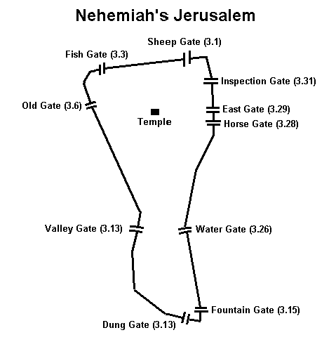
Illustration from jesus plus nothing web-site

