A Video that I watched on YouTube June 7, 2013
A few weeks ago, I came across a video on YouTube. The video was an interview with a homeless man in Chicago named Ronal Davis. It is an incredible 4 minute video of him just talking to the person holding the camera that practically brings me to tears each time that I watch it. The video has had over 2,000,000 views and has even inspired a series on WNIT called Asking Big Questions, and the video has certainly got me asking questions of myself.
After I first watched the video, I went on a business trip to Washington D.C. where I had a range of emotions from what I witnessed and took part in out there. From meeting with a Senator twice and meeting with a member of Congress, to seeing majestic buildings of incredible architecture and then to walking through a park 2 blocks away from The White House that was the home to many homeless people. It is certainly a city of extremes, which amplified further within me the emotions of watching the video of Ronald Davis. You can copy and past the link below into your browser to see the video:
http://www.youtube.com/watch?v=0rO0BHSPXQg&list=FLrnnC5lGJtIsYXDLTlGwq7w

Photo I took of the homeless park in D.C. at 9:30 pm one night
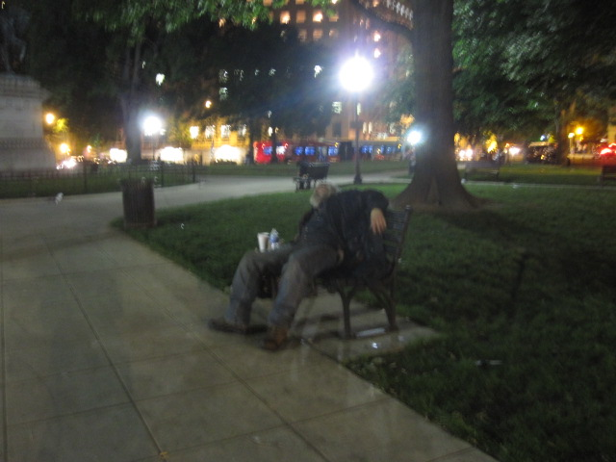

Matthew 5: 1-12 Now when Jesus saw the crowds, he went up on a mountainside and sat down. His disciples came to him, 2 and he began to teach them.
The Beatitudes
He said:
3 “Blessed are the poor in spirit, for theirs is the kingdom of heaven.
4 Blessed are those who mourn, for they will be comforted.
5 Blessed are the meek, for they will inherit the earth.
6 Blessed are those who hunger and thirst for righteousness, for they will be filled.
7 Blessed are the merciful, for they will be shown mercy.
8 Blessed are the pure in heart, for they will see God.
9 Blessed are the peacemakers, for they will be called children of God.
10 Blessed are those who are persecuted because of righteousness,for theirs is the kingdom of heaven.
11 “Blessed are you when people insult you, persecute you and falsely say all kinds of evil against you because of me. 12 Rejoice and be glad, because great is your reward in heaven, for in the same way they persecuted the prophets who were before you.

Matthew 6:1-4 “Be careful not to practice your righteousness in front of others to be seen by them. If you do, you will have no reward from your Father in heaven.
2 “So when you give to the needy, do not announce it with trumpets, as the hypocrites do in the synagogues and on the streets, to be honored by others. Truly I tell you, they have received their reward in full. 3 But when you give to the needy, do not let your left hand know what your right hand is doing, 4 so that your giving may be in secret. Then your Father, who sees what is done in secret, will reward you.
Matthew 7: 1-6 “Do not judge, or you too will be judged. 2 For in the same way you judge others, you will be judged, and with the measure you use, it will be measured to you.
3 “Why do you look at the speck of sawdust in your brother’s eye and pay no attention to the plank in your own eye? 4 How can you say to your brother, ‘Let me take the speck out of your eye,’ when all the time there is a plank in your own eye? 5 You hypocrite, first take the plank out of your own eye, and then you will see clearly to remove the speck from your brother’s eye.
6 “Do not give dogs what is sacred; do not throw your pearls to pigs. If you do, they may trample them under their feet, and turn and tear you to pieces.
Mark 10: 21-22 Jesus looked at him and loved him. “One thing you lack,” he said. “Go, sell everything you have and give to the poor, and you will have treasure in heaven. Then come, follow me.”
22 At this the man’s face fell. He went away sad, because he had great wealth.
Luke 4: 16-19 He went to Nazareth, where he had been brought up, and on the Sabbath day he went into the synagogue, as was his custom. He stood up to read, 17 and the scroll of the prophet Isaiah was handed to him. Unrolling it, he found the place where it is written:

18 “The Spirit of the Lord is on me, because he has anointed me to proclaim good news to the poor. He has sent me to proclaim freedom for the prisoners and recovery of sight for the blind, to set the oppressed free,19 to proclaim the year of the Lord’s favor.”[a]
Deuteronomy 15: 7-11 If anyone is poor among your fellow Israelites in any of the towns of the land the Lord your God is giving you, do not be hardhearted or tightfisted toward them. 8 Rather, be openhanded and freely lend them whatever they need. 9 Be careful not to harbor this wicked thought: “The seventh year, the year for canceling debts, is near,” so that you do not show ill will toward the needy among your fellow Israelites and give them nothing. They may then appeal to the Lord against you, and you will be found guilty of sin. 10 Give generously to them and do so without a grudging heart; then because of this the Lord your God will bless you in all your work and in everything you put your hand to. 11 There will always be poor people in the land. Therefore I command you to be openhanded toward your fellow Israelites who are poor and needy in your land.

Questions
- I frequently hear part of Deuteronomy 15:11 quoted by Christians “There will always be poor people in the land.” But when you read the rest of the scripture it adds more meaning. From Deuteronomy 15: 7-11, what stands out to you? How do you interpret what the scripture says for us to do and not to do? Do you feel that your interpretation is an accurate depiction of reality? If not, what can be done to change that reality?

- In the Beatitudes, Matthew 5: 1-12, Jesus unveils a way of living that contradicts the world’s way. How do you feel about this scripture?

- After reading Matthew 6: 1-4, how should we do this and still raise awareness for our cause?

- Matthew 7:1-6 This scripture, I think, is perhaps the hardest to abide by. What tips do you have to help others in staying true to this scripture?

- Mark 10: 21-22, How would you react if Jesus were to tell you this? Would you?

- Luke 4: 16-19, We have more in people in prison per 100,000 in population than any other country in the world (716), in November 2012 the US Census Bureau said that 16% of the US population lives in the poverty level which includes 20% of all children in the US. Statistics vary, but somewhere between 13-25% of all homeless are US Vets. According to the National Coalition for the Homeless, 41% of the homeless population are white (white is 76% of overall US population), African American makes up 40% of the homeless population (11% of overall US population), Hispanic 11% of homeless population (9% of overall US population) and Native American makes up 8% of the homeless population (1% of overall US population).
It seems as though we have a large target for this scripture and it seems as though Jesus made this scripture a priority, what can we do to change these numbers?

