Psalm 139:14 “I praise you because I am fearfully and wonderfully made; your works are wonderful, I know that full well.”
Last week’s study about attention and many of the other studies we have examined have allowed us to reflect on our priorities and how God can work through us if we make ourselves available and are attentive to the prompting of the Holy Spirit.
While we have spent time reflecting on the spiritual implications and nuances of our actions, we have not talked much about the role of our physical bodies in carrying out the will of God.
“The human body is unique, the most complex organism in the world, and that complexity and uniqueness speak volumes about the mind of its Creator. Every aspect of the body, down to the tiniest microscopic cell, reveals that it is fearfully and wonderfully made.” (https://faithhealth-wpengine.netdna-ssl.com/wp-content/uploads/we-are-wonderfully-and-fearfully-made-by-god.pdf)
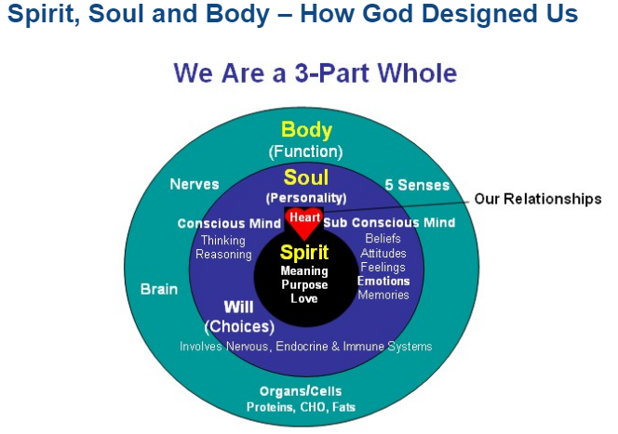
https://www.faithandhealthconnection.org/the_connection/spirit-soul-and-body/
The following link will take you to a Bible study written by Rick Warren. The five key points are listed below. - https://www.faithgateway.com/what-does-god-say-your-body/#.XQ_qP-hKiUk

1. My body belongs to God. It is His property, not mine. I don’t own it, God does. He created my body, and He expects me to use it the way He intended for it to be used.

2. Jesus paid for my body when He died for me on the cross.

3. God’s Spirit lives in my body.

4. God expects me to take care of my body.

5. God will resurrect my body after I die.

=================================================================

How Much Does God Want Me to Care for My Physical Body?
https://www.desiringgod.org/interviews/how-much-does-god-want-me-to-care-for-my-physical-body
“The reason people are unhealthy is because they're enslaved. They are enslaved to laziness, and they are enslaved to food. So they eat too much and they exercise too little. And they have heart attacks and get diabetes. And God would consider that a spiritual issue.
So we should strive spiritually. What did Paul mean when he said, "I will not be enslaved by anything?" He meant, "Christ is your master!"
And a third text that comes to mind is, "The fruit of the Holy Spirit is love, joy, peace, patience, kindness, goodness, gentleness, faithfulness, and ..." What? "Self-control," egkrateia (Galatians 5:22-23).
And again, largely sexual self-control is in view; but it's the same thing. The word "self-control" is not the best translation maybe, because it's really a work of the Holy Spirit.
So we should fight against anything that makes us unhealthy. If overeating makes us unhealthy, fight it by the Spirit. If laziness and lack of exercise makes us unhealthy, fight it with the power of the Holy Spirit. That is, believing the promises of God, praying down the Holy Spirit, and then biting the bullet and denying ourselves.
Christianity is self-denial ... for a higher joy. And I don't want my Christian hedonism to be taken to mean that everything is easy. It isn't.”
Scriptures:

1 Corinthians 6:19-20 ESV
Or do you not know that your body is a temple of the Holy Spirit within you, whom you have from God? You are not your own, for you were bought with a price. So glorify God in your body.

1 Corinthians 3:17 ESV
If anyone destroys God's temple, God will destroy him. For God's temple is holy, and you are that temple.

1 Corinthians 9:27 ESV
But I discipline my body and keep it under control, lest after preaching to others I myself should be disqualified.

1 Corinthians 3:16 ESV
Do you not know that you are God's temple and that God's Spirit dwells in you?

2 Peter 1:5-6 ESV
For this very reason, make every effort to supplement your faith with virtue, and virtue with knowledge, and knowledge with self-control, and self-control with steadfastness, and steadfastness with godliness,

Romans 12:1 ESV
I appeal to you therefore, brothers, by the mercies of God, to present your bodies as a living sacrifice, holy and acceptable to God, which is your spiritual worship.

Hebrews 12:11-12 ESV
For the moment all discipline seems painful rather than pleasant, but later it yields the peaceful fruit of righteousness to those who have been trained by it. Therefore lift your drooping hands and strengthen your weak knees,

Questions:
- How do we approach our service to God in a balanced way that recognizes and appreciates the spiritual and physical nature of our stewardship?

- How do we invest time and effort into keeping our bodies healthy without falling into the temptation of our culture to be overly concerned, obsessed, or narcissistic?

- How can we leverage our physical wellness routines to do God’s work? https://www.desiringgod.org/interviews/how-do-you-glorify-god-through-exercise

